www.iowaaap.org
Iowa Association of
Activity Professionals
2017 Conference Information Newsletter

The Board Members of the
Iowa Association of Activity Professionals
are proud to announce the
2017 Fall Conference
Thursday, October 19, 2017 &
Friday, October 20, 2017
at the
Gateway Conference Center
Ames, Iowa

Guest Speakers:
Barbara Speedling, Quality Life Specialist
Anthony Vicari, EDS, AC-BC, ACC/EDU, CADDCT, CDCM, CDP

Happy Summer to you all! Last Spring, Robin Schiltz and I attended the NAAP (National Association of Activity Professionals) Conference in Denver, Colorado the first week of April. The weather was gorgeous!! And the view of the mountains! I never get tired of looking at the mountains, the white fluffy cloud and enjoying the warm sunshine.
We attended great learning sessions, met new friends from all over the United States and got to visit with Vendors showing us the newest technology and sharing some old tricks. I believe there were 40 states represented and on the international front, a couple from Australia attended the conference. The 2018 NAAP Conference will be held in Philadelphia, Pennsylvania April 24th – April 27th.
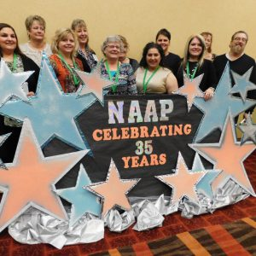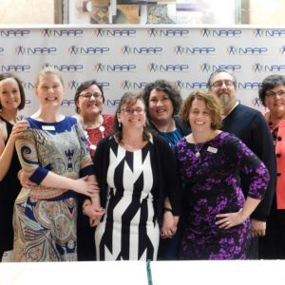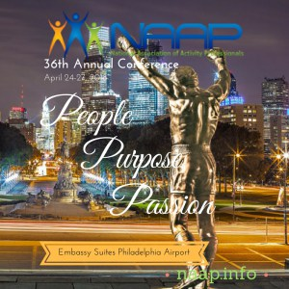
Let’s talk about “our” conference – Iowa Association of Activity Professionals. The annual Fall Conference will be October 19th and 20th, 2017 at the Gateway Conference Center in Ames, IA. On Thursday morning Barbara Speedling, Quality of Life Specialist, will speak on Discovering the Power of Meaningful Activities and other interesting topics in the afternoon.
And on Friday Anthony F. Vicari, EDS, AC-BC, ACC/EDU, CADDCT, CDCM, CDP and Vice President, National Association of Activity Professionals has a full day of informative, interactive sessions planned for us. Check out the conference agenda in this newsletter for a full line up of topics scheduled for those two days.
Mark your calendar! Register and book your lodging early to receive the discounted rates. We look forward to seeing you in October – Terri Tripp, IAAP President

Just a Reminder
Opportunity Basket Drawings
Fall Basket on Thursday
Winter/Holiday on Friday
$1 or 6/$5
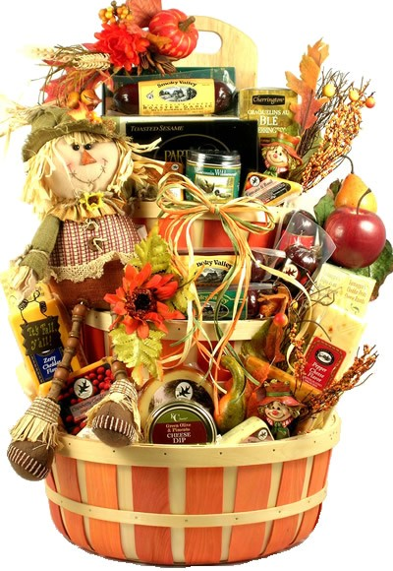
Baskets will vary from picture

CONFERENCE SCHOLARSHIPS
We want to help you attend this conference. IAAP will again be sponsoring two (2) scholarships in the amount of the registration of the 2-day fall conference. Scholarships are to assist individuals who do not receive financial support.

For further information on the scholarship criteria, see form in this newsletter.

Websites to Visit

www.naap.info
National Association of Activity Professionals
For the national activity news and information

www.nccap.org
National Certification Council of Activity Professionals
For regulations and certification information

www.iowaaap.org
Iowa Association of Activity Professionals
For Iowa Activity information, newsletter, and links to other activity professional related sites.

Iowa Association of Activity Professionals
FALL Conference Schedule
Thursday, October 19th, 2017

BOTH DAYS:
Registration, rolls & coffee
7 to 8 a.m.
Lunch and Networking

Thursday’s Topics by Barbara Speedling
Discover the Power of Meaningful Activities
Music and Meaning in Dementia Care
Improving the Care of Residents with Dementia
A Networking Session

Friday’s Topics by Anthony F. Vicari, EdS
Creating and Maintaining ‘A+’ --
Recreation/Activity Professional Teams
They are moving into Long-Term Care: --
What Are We Doing for Them?
The Power of Creative Arts: Photography,
Words, Music and the Brush!
Seniors: Yes, They Can Be Bullies, Too!

Continuing Education Credits Information
Thursday hours will provide 6 hours for the 4 speaker sessions. An extra hour has been added for the networking session. It will run from 4 to 5 p.m.

Friday hours will provide 6 hours for the 4 speaker sessions. We will dismiss at 4 p.m. to allow travel time home.
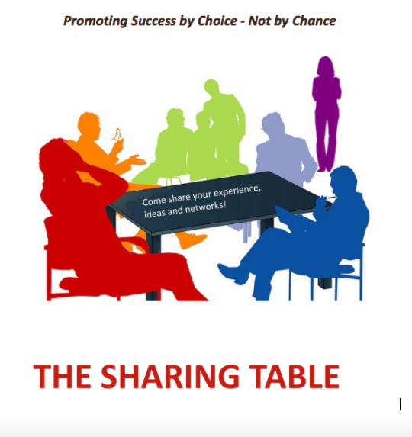
Sharing Table
Do you have a craft or a game idea that was well received by your residents? Bring a sample along with copies of instructions (80) to share with others.
A table will be set up for displaying these ideas.
We’ve all seen ideas on Facebook but would like to see what Activity Professionals think of the projects!

About Our Presenters
Barbara Speedling,
Quality of Life Specialist

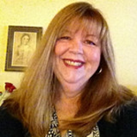Barbara Speedling, Quality of Life Specialist, is a New York based quality management consultant who provides education, training and support to community, residential and long-term care providers in the development of programs and services to meet a broad range of behavioral health needs. Guidance is offered in maintaining regulatory compliance and improving the quality of care and quality of life of individuals with Alzheimer’s disease and related dementia, mental illness, brain injury and complex psychosocial needs.​​
In keeping with the core values of person-centered care, Barbara works closely with providers to evaluate and develop individualized approaches to the behavioral and psychosocial needs of their clients. Built on the belief that quality of life will be defined differently for each individual, this approach offers a fresh perspective on assessment and care planning for those with special needs and challenging behavior.

As an educator on meeting the psychosocial and behavioral challenges of varied populations, Barbara has earned a reputation for helping caregivers to think differently about the people they care for. In 2014, she authored, “Why is Grandma Screaming? A Practical Guide to Improving Quality of Life in Long Term Care,” in which she offers common sense advice on meeting the holistic needs of an increasingly diverse and challenging community.
Over time, she has applied her understanding of human behavior to education and training programs designed to support leadership and organizational development, cultural intelligence and empathetic approaches to care and treatment. Her training programs on customer service and caregiver sensitivity have helped many facilities to achieve a true culture change in thinking and service delivery.
Barbara began her career in long-term care working in recreation therapy in an intermediate care facility in Ohio that provided services to both pediatric and adult residents with cognitive, intellectual and psychiatric needs. She later began specializing in the development of environments and programs for people diagnosed with Alzheimer’s disease, mental illness and other psychosocial challenges.
Her experience spans admissions, marketing and public relations, patient advocacy, quality management and community outreach. She has helped many facilities develop specialized programs and environments designed to overcome a broad range of behavioral health challenges.
Barbara completed her BS in Healthcare Administration at Empire State College, SUNY. Her undergraduate work included extensive study in music and the arts at Kent State University prior to relocating to New York in 1986. She is an accomplished musician and artist, skills that have enhanced the development of her interventions in behavioral health.
In addition to her professional involvement, Barbara is a resource to families in her community, volunteering her time and talents to caregiver education and support. Through her affiliation with local artists and musicians in her native Queens, NY, Barbara also arranges therapeutic music, dance and wellness programming for seniors in her local community to enhance their quality of life.

Anthony F. Vicari
Certified Alzheimer’s Disease and Dementia Care Trainer
Activity Consultant Certified ~ Education Specialization
Activity Consultant~Board Certified
Certified Eden Alternative Educator and Associate
National Association of Activity Professionals’ Vice President

Anthony is an active educator in today’s health care profession. His 2016 ‘Presentation Venue’ includes the following cities: Fort Morgan, Colorado; St. Cloud, Minnesota; Kenai, Alaska; Fernley and Carson City, Nevada; Las Vegas and Mesquite, Nevada.
Anthony currently serves as the Vice President for the National Association of Activity Professionals. One of Anthony’s professional highlights was serving as Professional Development Trustee for the National Association of Activity Professionals; 2012-2015. Anthony was directly responsible for orchestrating and delivering three Education Summits: St. Louis, Missouri, 2012; New Orleans, Louisiana, 2013; and Sacramento, California, 2014. In addition, he was directly responsible for the organization of three National Conferences; Las Vegas, Nevada, 2013; St. Louis, Missouri, 2014, and Daytona Beach, Florida, 2015. Each of these educational conferences was nationally approved for Continuing Education hours and provided health care attendees with practical and research-based strategies and experiences.
Anthony is nationally certified as an Activity Consultant Certified/Education Specialization (ACC/EDU) through the National Certification Council for Activity Professionals; an Activity Consultant-Board Certified (AC-BC) through the National Association of Activity Professionals Credentialing Center; a Certified Alzheimer’s Disease and Dementia Care Trainer (CADDCT), Certified Dementia Care Manager (CDCM), and Certified Dementia Practitioner (CDP) through the National Certification Council of Dementia Practitioners; and a Certified Eden Alternative Trainer and Associate through the Eden Alternative.
Anthony’s 37 years of professional work includes the following settings: adult and geriatric behavioral health hospitals; memory care neighborhoods; continuous care retirement communities; skilled nursing centers; and public/private education as school administrator and educator. He enjoys serving residents and families in a variety of settings and has presented education seminars specifically dealing with Alzheimer’s Disease and Dementia Care at the local, state and national levels. Anthony believes that the essential experiences and knowledge gained from his years of service helps in every aspect of his professional presentations.
Finally, Anthony is a published author with R.O.S. Therapy Systems: Caregiver Activity Lesson Plans, Volume I; Leading Age Georgia; Freiberg Press; the National Certification Council of Dementia Practitioners; and the National Association of Activity Professionals. His writings are current and research-proven for all health care settings, providing meaningful and engaging education, specifically addressing Quality of Life issues and effective programming and strategies for health care professionals working with persons living with Alzheimer’s/Dementia.

Scholarship Criteria

The following is the criteria to be considered for one (1) of two (2) scholarships in the amount of the registration for the 2017 Fall Conference.

- You must meet one (1) of the following:
a. Employed in the activity or related field
b. Volunteer at least 75 hours of service yearly
c. Presently are enrolled in a state-approved course
- Enrolled in a four-year program related to the field (CRTS)

- You may be eligible to receive the award one (1) time every three (3) years.

- The amount awarded will be the amount of registration (no cash value).

To be eligible, you need to complete and attach an essay of 50 words or less about how you believe this conference will benefit your working with the elderly. Include your name, home address, home phone number, e-mail address, and facility name and work phone number. Also include if you receive any other financial assistance to attend this conference (i.e. from your organization/corporation).

ALL applications need to be received by Chris by September 15th, 2017. You will be notified by September 22rd, 2017 if you are a recipient.

Send by September 16, 2017 to
Chris Thomas, IAAP Treasurer
1116 Hazel
Pella, IA 50219
Fax # 641-620-4194 E-Mail: cthomas@wesleylife.org

Iowa Association of Activity Professionals
2017 Fall Conference Registration
Thursday, October 19, and Friday, October 20, 2017

Name: ___________________________________________________
Facility Name: ____________________________________________
Address: _________________________________________________
Please circle: home address facility address
City, State, Zip: ___________________________________________
Phone: __________________________________________________
Please circle: home/cell phone facility phone
E-Mail: __________________________________________________
Please circle: home e-mail facility e-mail
________ I have no e-mail. Please contact me by phone or mail as needed.
REGISTRATION OPTIONS: Please indicate your selection with an X
______ Both days, if registering BEFORE October 6th $175
______ Both days, if registering AFTER October 7th $190
______One day**, if registering BEFORE October 6th $115
______ One day**, if registering AFTER October 7th $130
**Please circle which day you will be attending THURSDAY or FRIDAY

Please make copies and fill out a SEPARATE SHEET for each person registering for the conference
____Please check if faxing registration and mailing check
Please be sure your facility is mailing registration and payment
with checks payable to IAAP to:
Chris Thomas, IAAP Treasurer
1116 Hazel
Pella, IA 50219
Or faxed to 641-620-4194

If questions, please contact Chris
Email: cthomas@wesleylife.org
Cell: 641-780-0200; Home: 641-628-2032
Work: 641-620-4190

CONFERENCE INFORMATION
Directions:
The Gateway Center is located at US highway 30 and University Drive.
--Off I-35, take exit 111B to Highway 30 West. Exit onto University Blvd. and go west. The entrance to Gateway is on the right.

Dietary Concerns:
If you have any dietary concerns, please contact Terri Tripp: cell: 515-314-6401
Work: 515-255-3499 E-Mail: ttripp@newburyliving.com

Hotel Rooms:
Make your reservations for The Gateway Hotel and Conference Center
At 515-292-8600 or toll free- 1-800-FOR-AMES (800-367-2637)
Website: gatewayames.com Ask for special rates for the Iowa Association of Activity Professionals Conference.

Reminders:
The rooms at the Gateway Conference are USUALLY COOL. Please dress appropriately and/or bring a sweater or jacket to put on.

Cell Phone Usage:
Please be courteous about cell phone usage. We ask you to utilize the vibrate options for calls and other services. Please step outside the meeting room to take a call. Cell phone usage is a distraction to the speakers as well as the participants. This includes checking social apps during presentation times.

As Always----
**If you have any ideas you’d like to share, send information to Jeri at iaapjeri@hotmail.com to print out. If you can bring a sample, SUPER!
**If you would like to share your facility’s activity calendar, email it to iaapjeri@hotmail.com to electronically send to conference attendees with e-mail addresses.
**If you have any websites that have been particularly helpful to you, email iaapjeri@hotmail.com to spread the word.
**In other words—if you have ANYTHING you would like to share, email to iaapjeri@hotmail.com

